Software Design Document

For Minor Project

Shellinabox



|  |  |
| --- | --- |
| Prepared by:  Achal Sharma(Pce15it002)  Riya Gupta(Pce15it046)  Vijaya Nandwana(Pce15it062) | Guide:  Mr. Amol Saxena  Head of Department  (Information Technology) |
| Department of Information Technology,  Poornima College of Engineering | |
| 3 November 2018 , Session – 2018-19  **Table of Contents**   |  |  | | --- | --- | | Table of Contents | Page No. | | 1. Introduction | 3. | | **2. Architectural Design (System Flow Chart,)** | 4. | | UML(Class Diagram) | 5. | | **3. Database Diagrams** | 5. | | 4. GUI Design | 7. | | 5. Glossary | 14. | | 6. References | 14. | | 10. Guide’s Comments | 14. | | |

1. **Introduction**
   1. **Purpose**

This project is based on the Cloud based and Bigdata based Scalable Organization Management System with Semantic Web, Mobile Interface that will serve as a foundation for the final product. It is planned to satisfy everyone’s expectations. The Shellinabox is intended to provide a quick, easy and user-friendly cloud-based services like SaaS, PaaS, CaaS, IaaS, StaaS and data analytics which is done through hadoop services. The system should be designed so that management time is minimized and the product is available to clients at a very economical price. All the Services are available under a single portal.  [Software Design Specification](https://en.wikipedia.org/w/index.php?title=Software_Design_Specification&action=edit&redlink=1) is a written description of a [software](https://en.wikipedia.org/wiki/Software) product, that a software designer writes in order to give a [software development](https://en.wikipedia.org/wiki/Software_development) team overall guidance to the architecture of the software project. An SDD usually accompanies an architecture diagram with pointers to detailed feature specifications of smaller pieces of the design. Practically, the description is required to coordinate a large team under a single vision, needs to be a stable reference, and outline all parts of the software and how they will work.

* 1. **Feasibility**
     1. The web-App reduces the effort and time of the clients. People spend a lot of time in finding an appropriate platform which provide secure services. This web-app serve their purpose by giving them better user experience without much investment. The web-app will be made accessible to Enterprise, Professionals and Students. The data deployed by the users is secure and have backups also there is no fear of losing confidential data. The services are made accessible to the targeted clients using WebUI Techniques which makes it easier for the clients to access these service.

1. **Architectural Design (System Flow Chart)**

**System Architecture**

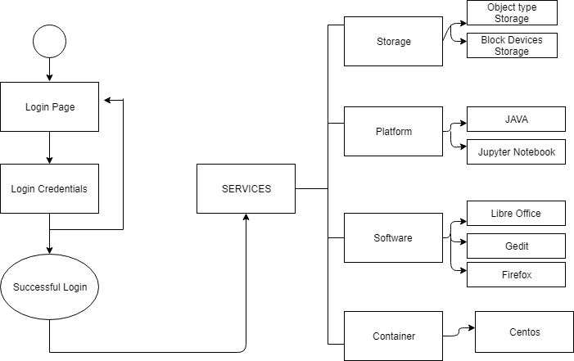

**Class Diagram**

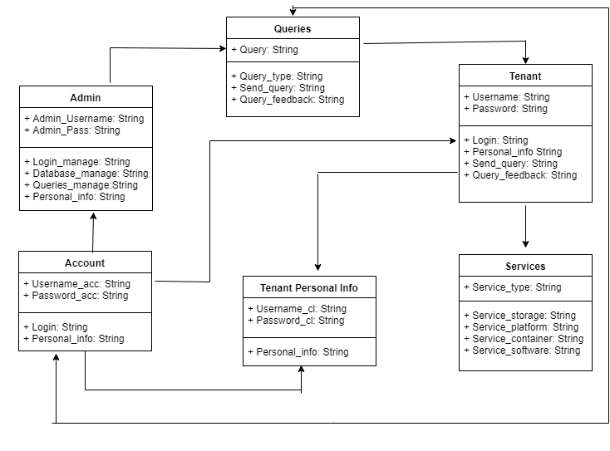

1. **Database Diagrams**
   1. **Database Design of Registration**

|  |  |  |
| --- | --- | --- |
| **Field Name** | **Datatype** | **Key Constraints** |
| Username | Varchar | PRIMARY KEY |
| First name | Varchar | NOT NULL |
| Password | Varchar | NOT NULL |

**4.2 Database Design of Login**

|  |  |  |
| --- | --- | --- |
| **Field Name** | **Datatype** | **Key Constraint** |
| Username | Varchar | NOT NULL |
| Password | Varchar | NOT NULL |

**4.3 Database design for Containerization**

|  |  |  |
| --- | --- | --- |
| **Field Name** | **Datatype** | **Key Constraint** |
| Container name | Varchar | PRIMARY KEY |
| Version | Varchar | NOT NULL |
| Creation date | Varchar | NOT NULL |
| Status | Varchar | NOT NULL |
| Operating System | Varchar | NOT NULL |

**4.4 Client Management Database**

|  |  |  |
| --- | --- | --- |
| **Field Name** | **Datatype** | **Key Constraint** |
| IP Address | Int | PRIMARY KEY |
| Hostname | Varchar | NOT NULL |
| Service Type | Char | NOT NULL |
| Protocol | Char | NOT NULL |

**4.5 Container as a Service Database**

|  |  |  |
| --- | --- | --- |
| **Field Name** | **Datatype** | **Key Constraint** |
| Status | Char | NOT NULL |
| Container Name | Varchar | PRIMARY KEY |
| Container Image | Char | NOT NULL |

**4.6 Software as a Service**

|  |  |  |
| --- | --- | --- |
| **Field Name** | **Datatype** | **Key Constraint** |
| IP Address | Int | PRIMARY KEY |
| Software Name | Char | NOT NULL |
| Container Name | Char | NOT NULL |

**4.7 Storage as a Service**

|  |  |  |
| --- | --- | --- |
| **Field Name** | **Datatype** | **Key Constraint** |
| IP Address | Int | PRIMARY KEY |
| Hostname | Varchar | NOT NULL |
| Storage Type | Char | NOT NULL |

**4.8 Platform as a Service**

|  |  |  |
| --- | --- | --- |
| **Field Name** | **Datatype** | **Key Constraint** |
| IP Address | Int | PRIMARY KEY |
| Platform Name | Varchar | NOT NULL |
| Container Name | Char | NOT NULL |

**4.9 Hadoop Services**

|  |  |  |
| --- | --- | --- |
| **Field Name** | **Datatype** | **Key Constraint** |
| Status | Char | NOT NULL |
| Container Name | Varchar | PRIMARY KEY |
| Number of nodes required | Int | PRIMARY KEY |

1. **GUI Design**
   1. **Design for Signup Page**

This is signup page. if client want to access our website then it can fill this form first to connect with our website. it is a first step for a new client. In this client can enter a unique number it is a port number of docker so it is different number for different client.

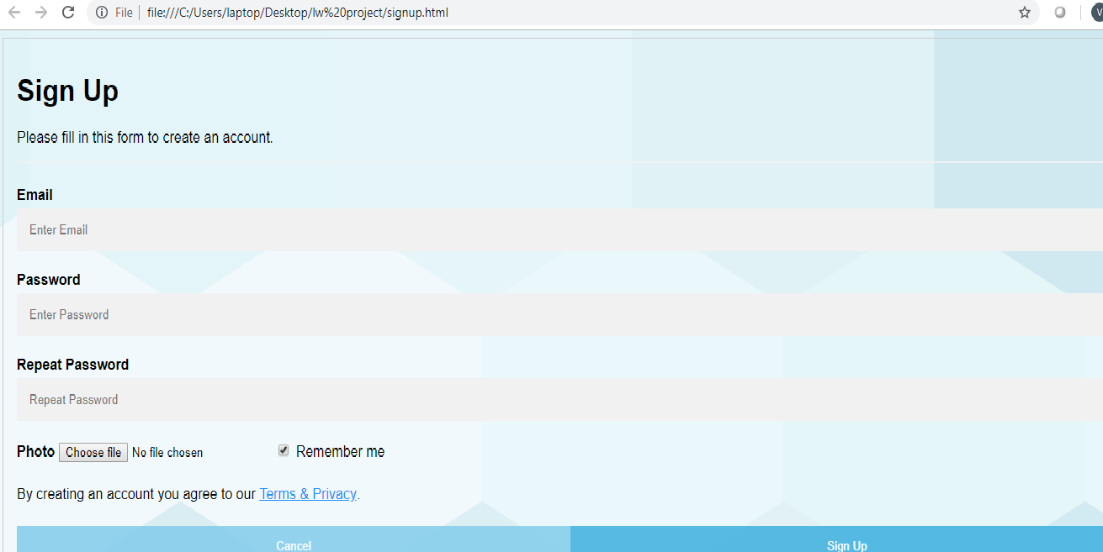

* 1. **Design for login page**

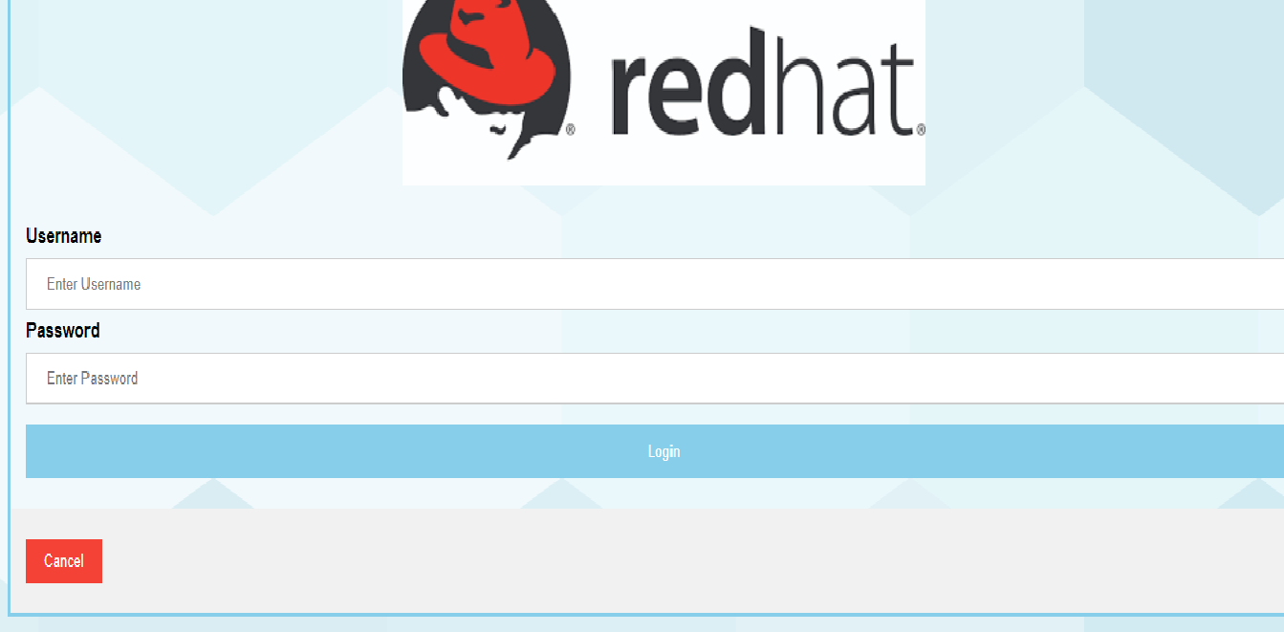

* 1. **GUI design for Service page**

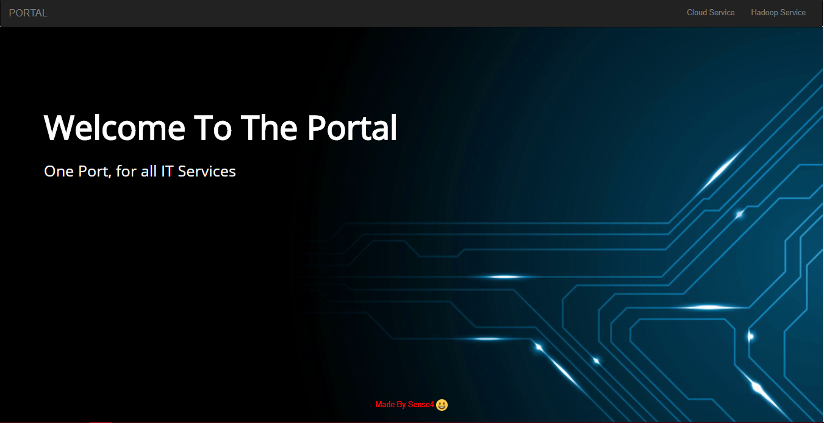

* 1. **GUI design for front page**



* 1. **GUI design for cloud portal**

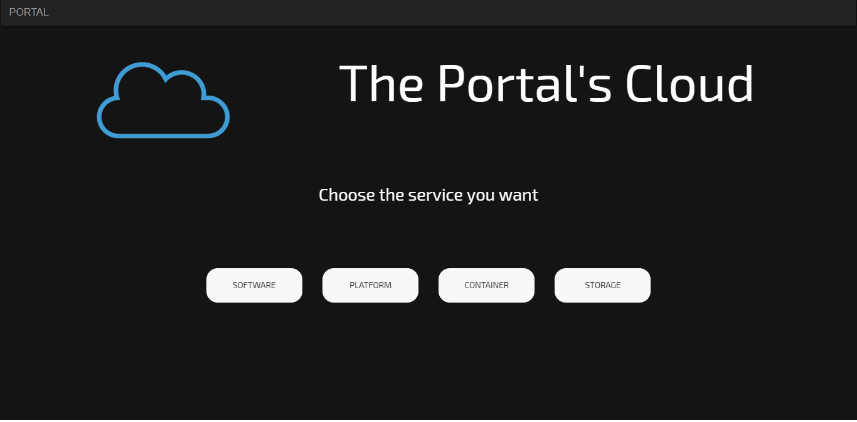

**4.6 GUI Design for SAAS**

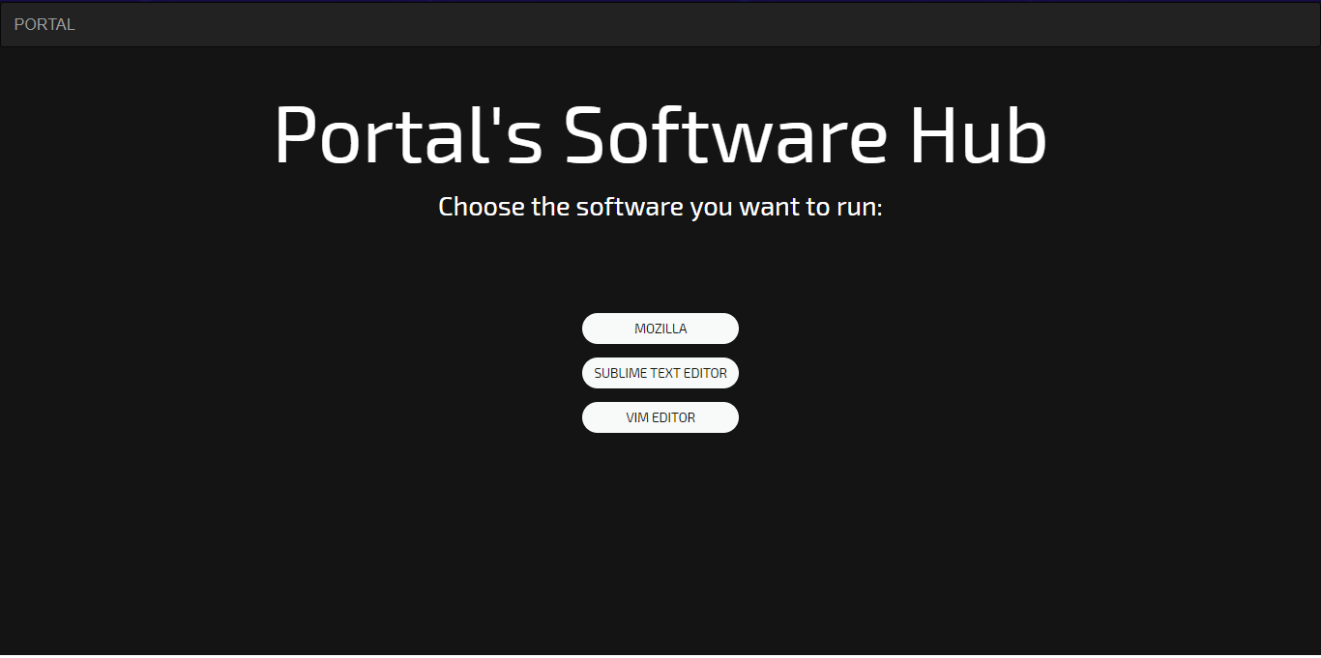

* 1. **GUI Design for PAAS**

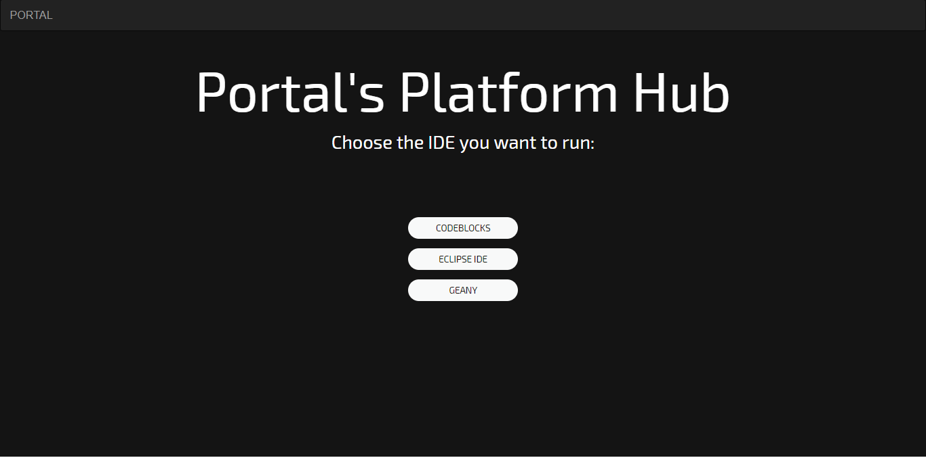

* 1. **GUI Design for CAAS**

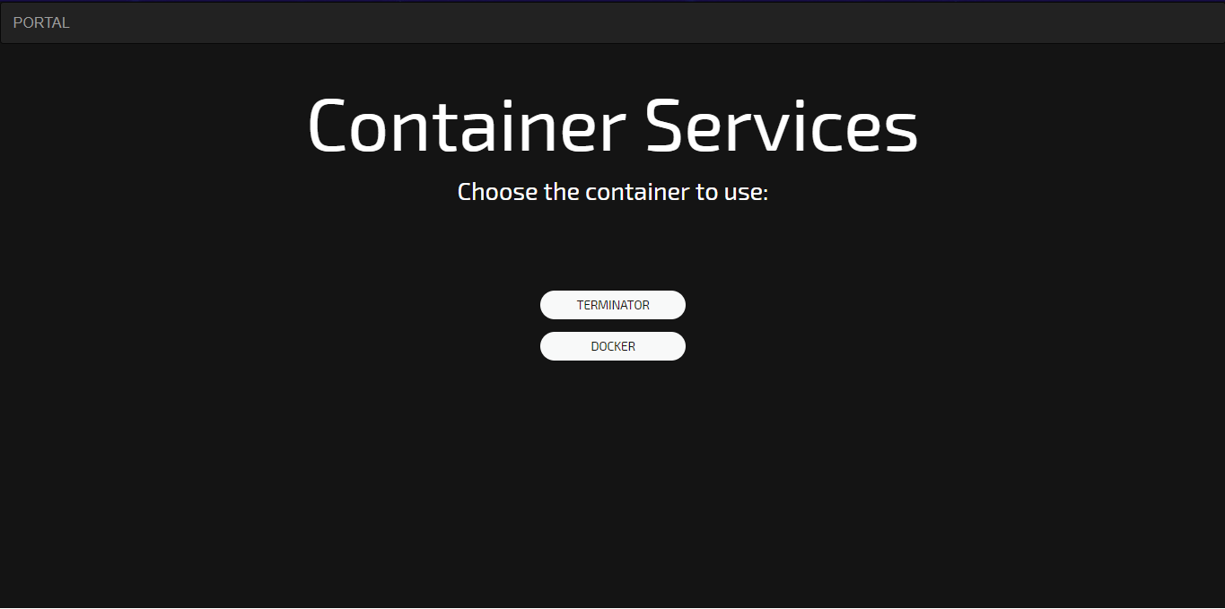

* 1. **GUI Design for STaas**

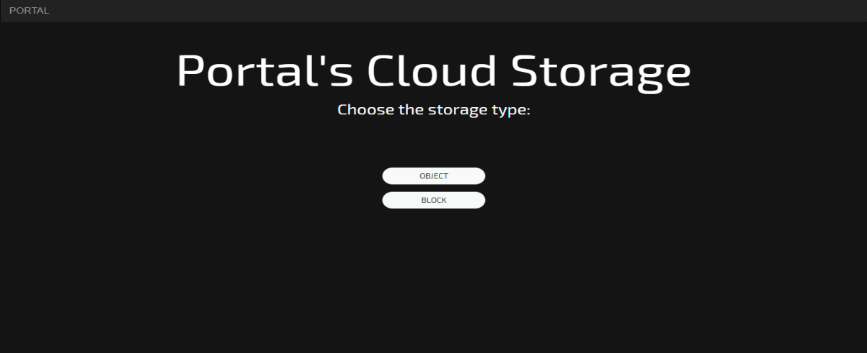

* 1. **GUI design for BigData Services**

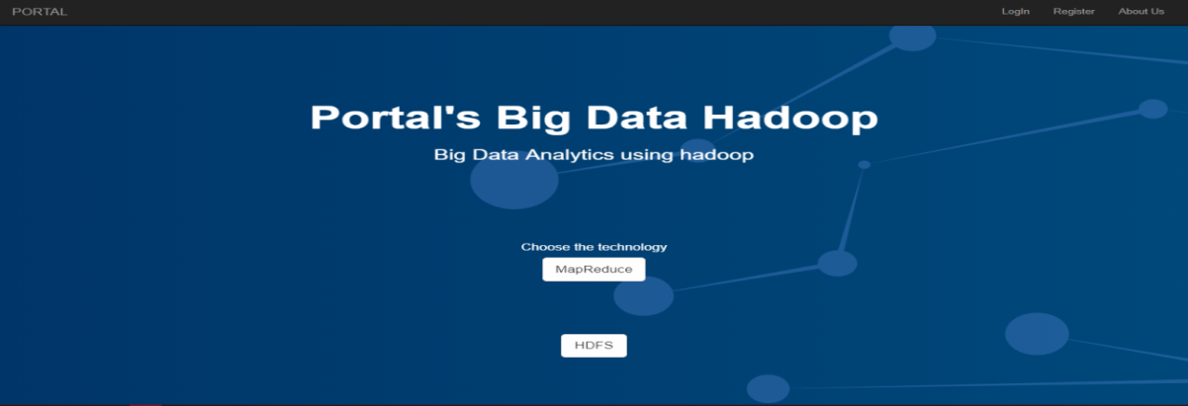

* 1. **GUI design for Bigdata configuration**

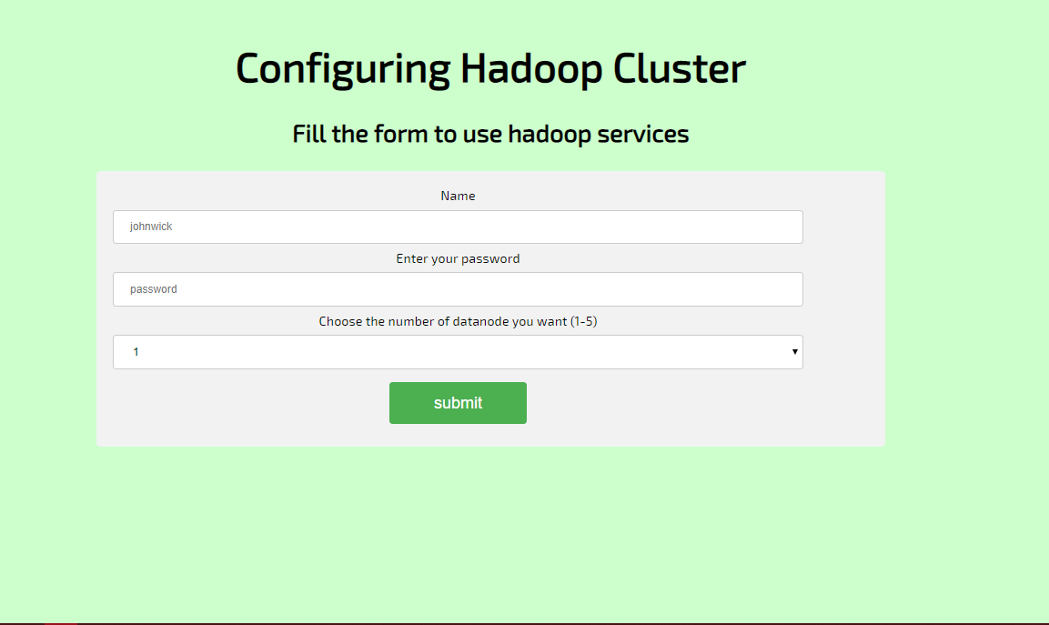

1. **Glossary**

|  |  |
| --- | --- |
| **RHEL** | Red Hat Enterprise Linux |
| **API** | Application Programmable Interface |
| **CaaS** | Container as a Service |
| **PaaS** | Platform as a Service |
| **StaaS** | Storage as a Service |
| **IaaS** | Infrastructure as a Service |
| **SaaS** | Software as a Service |

# References

* www.redhat.com
* www.searchcloudcomputing.techtarget.com
* www.techopedia.com
* access.redhat.com
* <http://w3schools.com>

# Guide’s Comments

**-----------------------------------------------------------------------------------------------------------------------------------------------------------------------------------------------------------------------------------------------------------------------------------------------------------------------------------------------------------------------------**